Appendix J-5

Thesis/Project 2 Meeting Record Assessment Rubric

|  |  |  |  |
| --- | --- | --- | --- |
| **Project/Thesis 2 Logbook Rubric** | | | |
| **Group No.:** |  | | |
| **Project:** | **Enhancing File Sharing and Data Management Capabilities at Batangas State University Alangilan Faculty Through a Distributed File System** | | |
| **Adviser:** | Mark Rondol P. Abdon | | |
| **Logbook Assessment (10%)** | | | |
| 1. Number of Meetings with Supervisor – these are weekly meetings which took  place between the student and the supervisor and the relevant meeting record sheet was documented. | | | |
| **Area 1** | | **Number of Meetings** | **Total score** |
| Number of meetings held during the 18 weeks semester period | | None | 0 |
| Less than 5 | 10 |
| 5 to 6 | 15 |
| 7 to 8 | 25 |
| 9 to 10 | 35 |
| More than 10 | 40 |
| **Area 1 score** | | |  |
| 2. Progress Report – Execute and lead research project planning, budget, direct and control tasks, resources effectively (which has been indicated in the meeting record). | | | |
| **Area 2 score ( 1 to 5)** | | **Progress Report** | **Total score** |
| Average completion of agreed tasks during the semester | | Completed none | 0 |
| Completed at least 25% | 20 |
| Completed at least 50% | 30 |
| Completed at leaset 75% | 40 |
| Completed at least 85% | 50 |
| Completed 100% | 60 |
| **Area 2 score** | | |  |

**Total score out of 100 (Area 1 + Area 2)**

**Other comments**

***\*Please key into white coloured cells only***

**SUMMARY OF LO SCORES %**

|  |  |  |
| --- | --- | --- |
| **LO7** |  |  |
|  |  |  |

**CONVERTED MARKS (%)**

|  |  |
| --- | --- |
| Objectives | Percentage |
| 1. To develop a website that has the following capabilities:   1.1 Upload **40%**  1.2 Download **80%**  1.3 Share **0%**  1.4 Search; and **0%**  1.5 Encryption of files **0%** | **24%** |
| 1. To incorporate web application and Distributed File System with the campus network's existing infrastructure for enhanced file management and access capabilities. | **0%** |
| 1. To create a DFS replication group to automatically synchronize and replicate data between designated servers for redundancy and data recovery. | **0%** |
| 4. To map the virtual DFS path to the actual physical location of the files in the server using Django Framework. | **0%** |

**Engr. Mark Rondol P. Abdon**

Adviser

|  |  |  |  |  |
| --- | --- | --- | --- | --- |
| **Dr. Jeffrey S. Sarmiento** |  | **Dr. Jen Aldwayne Delmo** |  | **Engr. Mark John Fel Rayos** |
| **Panel Chairman** |  | **Panel Member** |  | **Panel Member** |

Here's the latest version of the sign-up page in our web app, reflecting the ongoing improvements we've made to enhance its design and functionality.

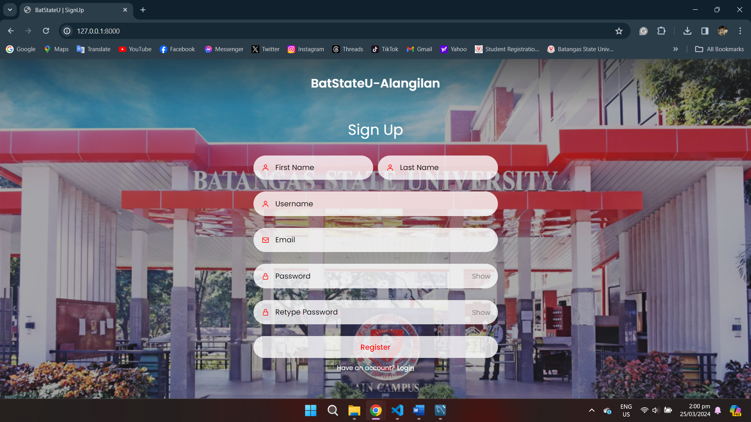

Here's the current login page of our web application, reflecting the latest updates and enhancements in its design and features.

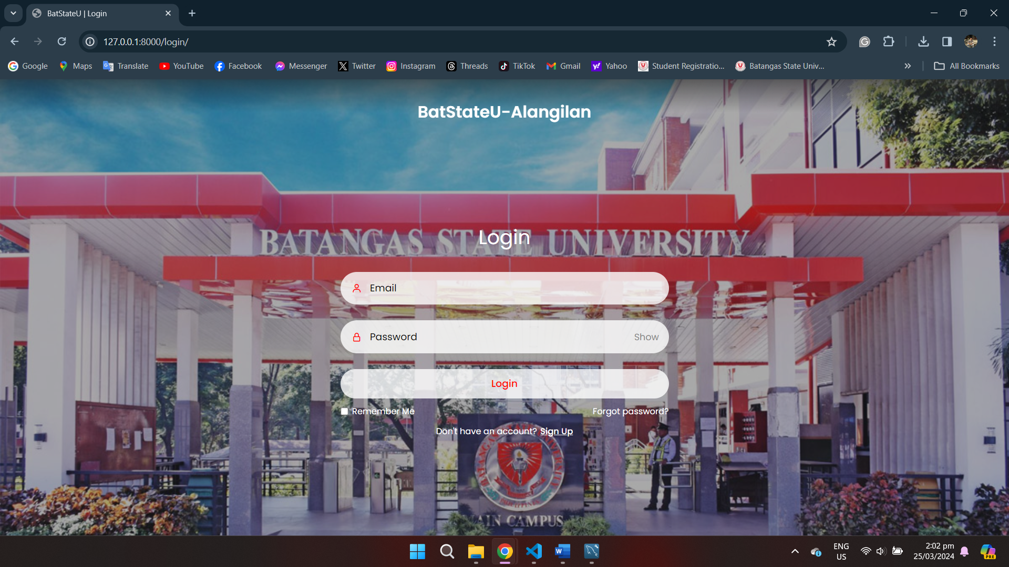

The upload button and download function are now accessible, but we're still working on enabling folder uploads. Additionally, the dashboard design hasn't been coded yet, but it's in development.

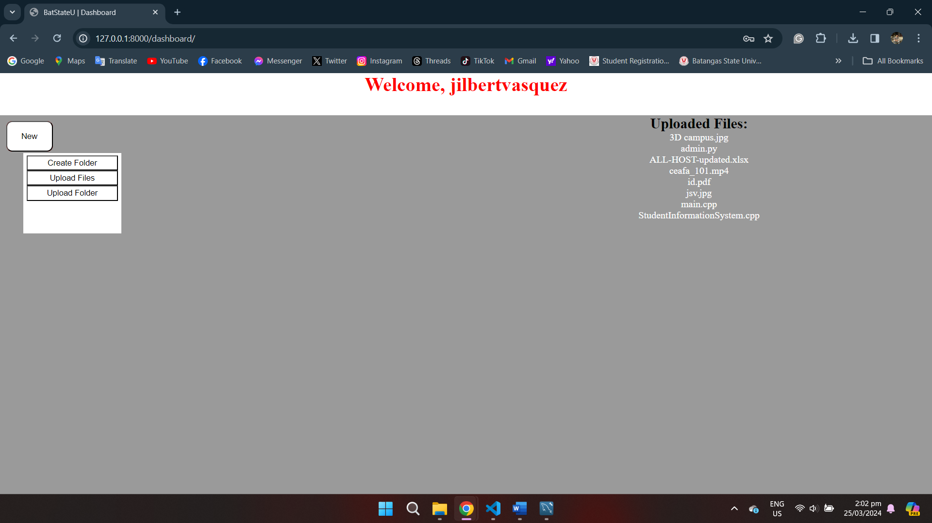

This is the current design of the dashboard for our web application, although it's not yet in development. Changes may occur as we continue to work on the web application. However, the core functionalities will remain intact within the application.

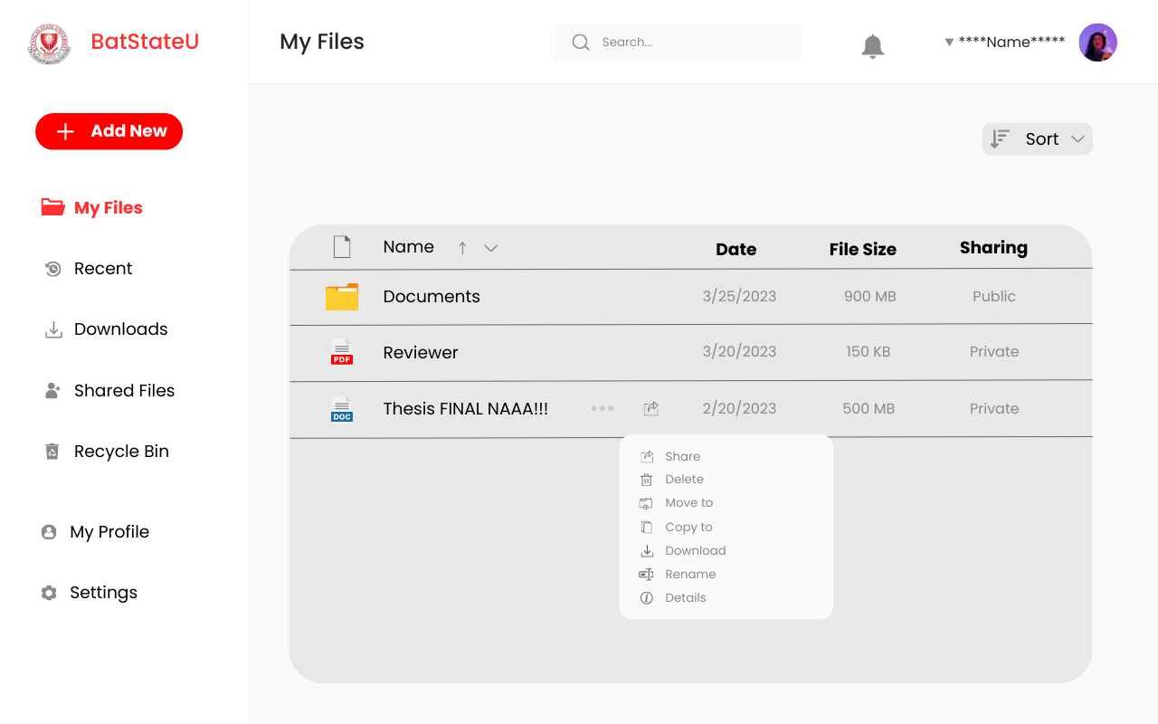

Here's the current login code for the web application.

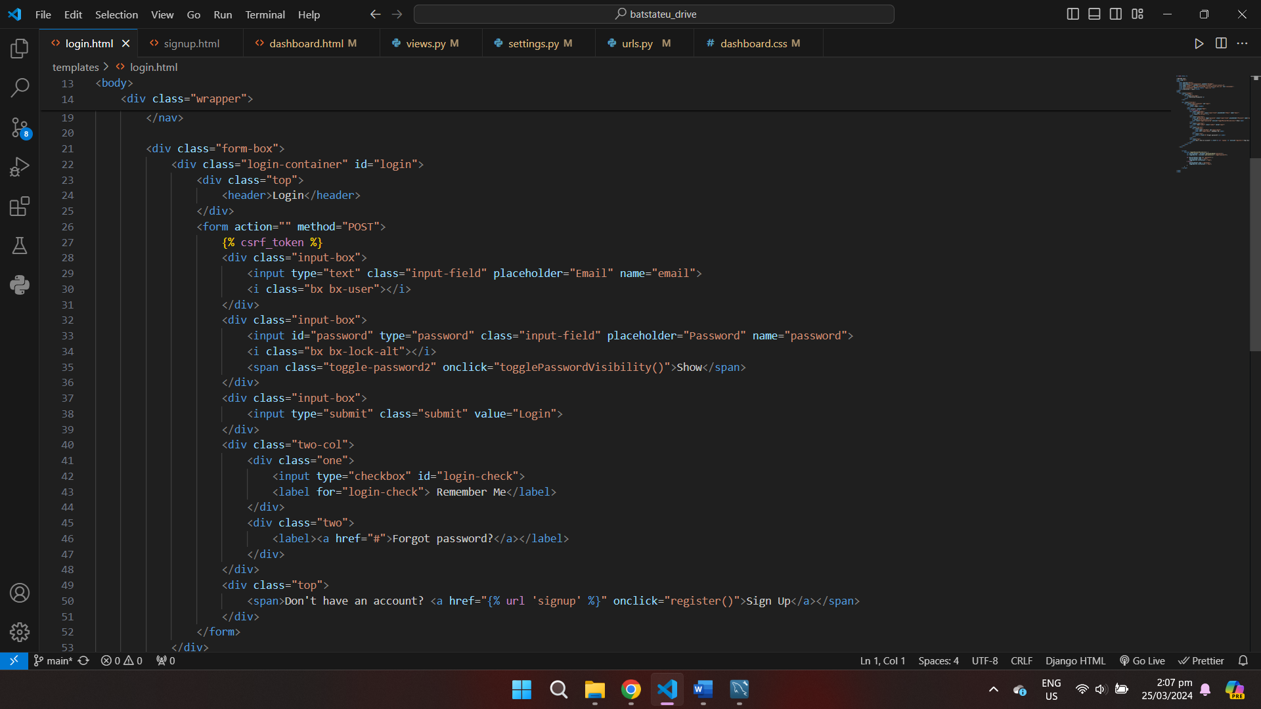

Here's the current sign-up code for the web application.

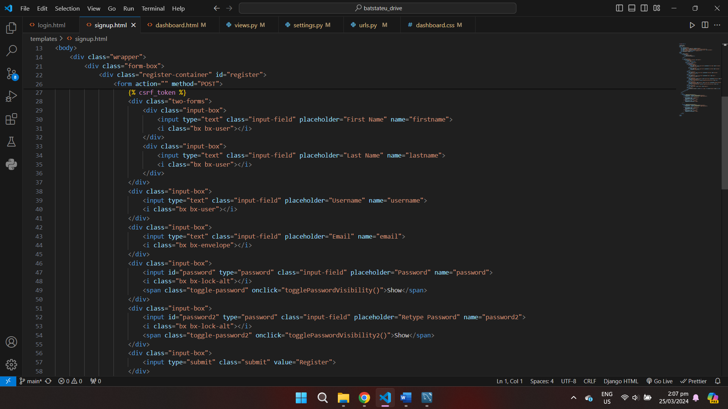

Here's the current dashboard code for the web application.

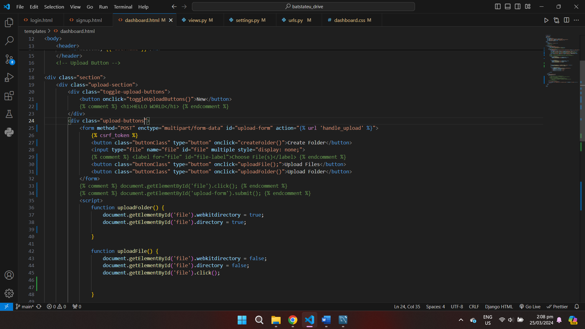

View files are where you'll find specific functions performed, such as managing request methods, handling login processes, and facilitating interactions with the database.

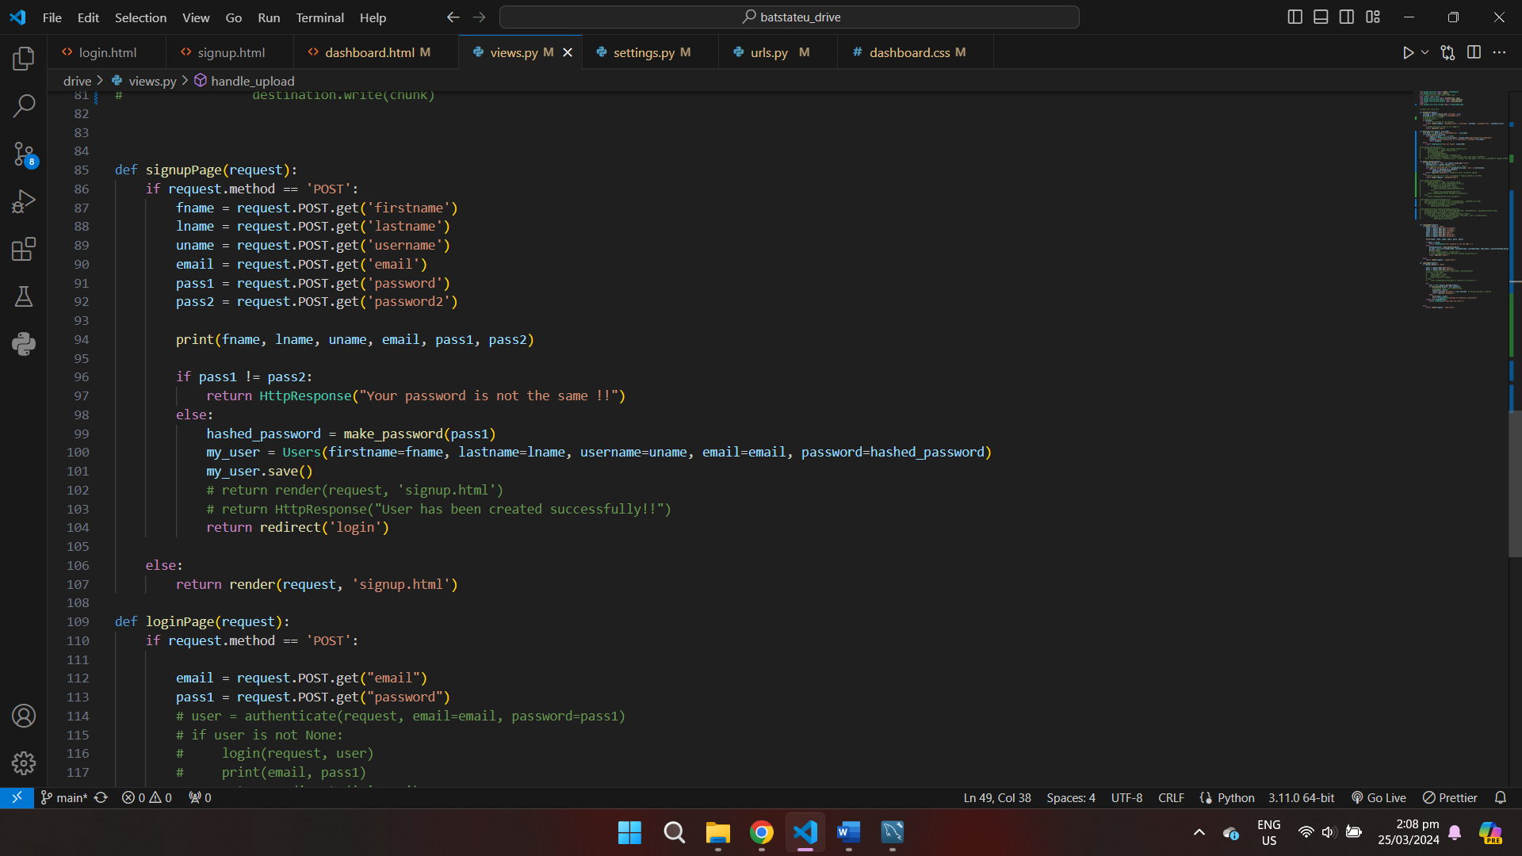

The URL file is where you specify paths and associate them with the respective functions inside the views files.

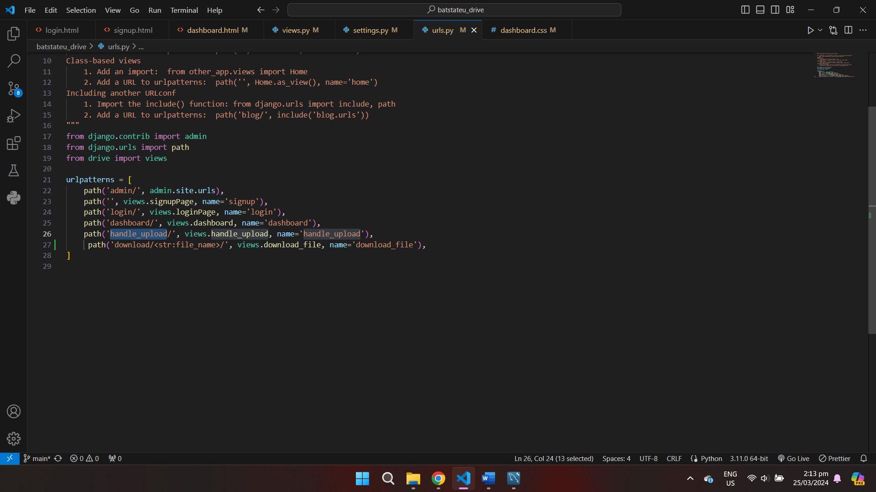

To change the default database in Django from SQLite to MySQL, modify the project's settings.py file's DATABASES option to include MySQL as the new database engine.

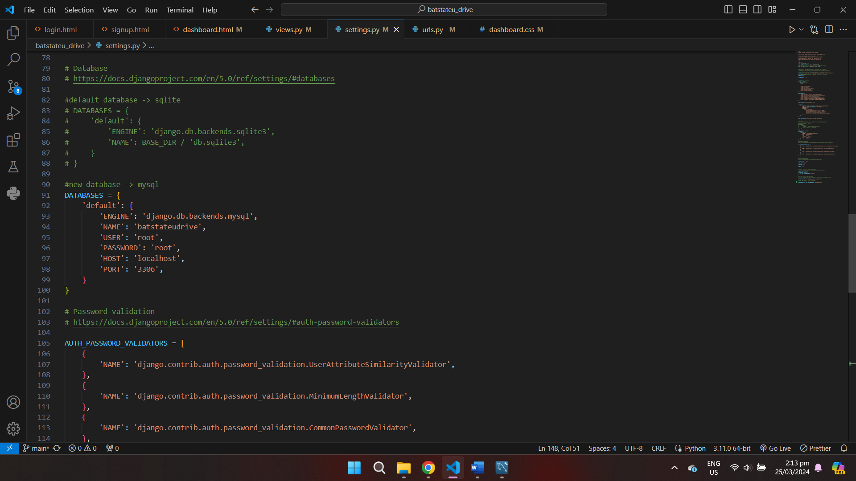

We're importing a model created in Workbench into the Django Framework; this is just one of the many models to be utilized throughout the entire web application.

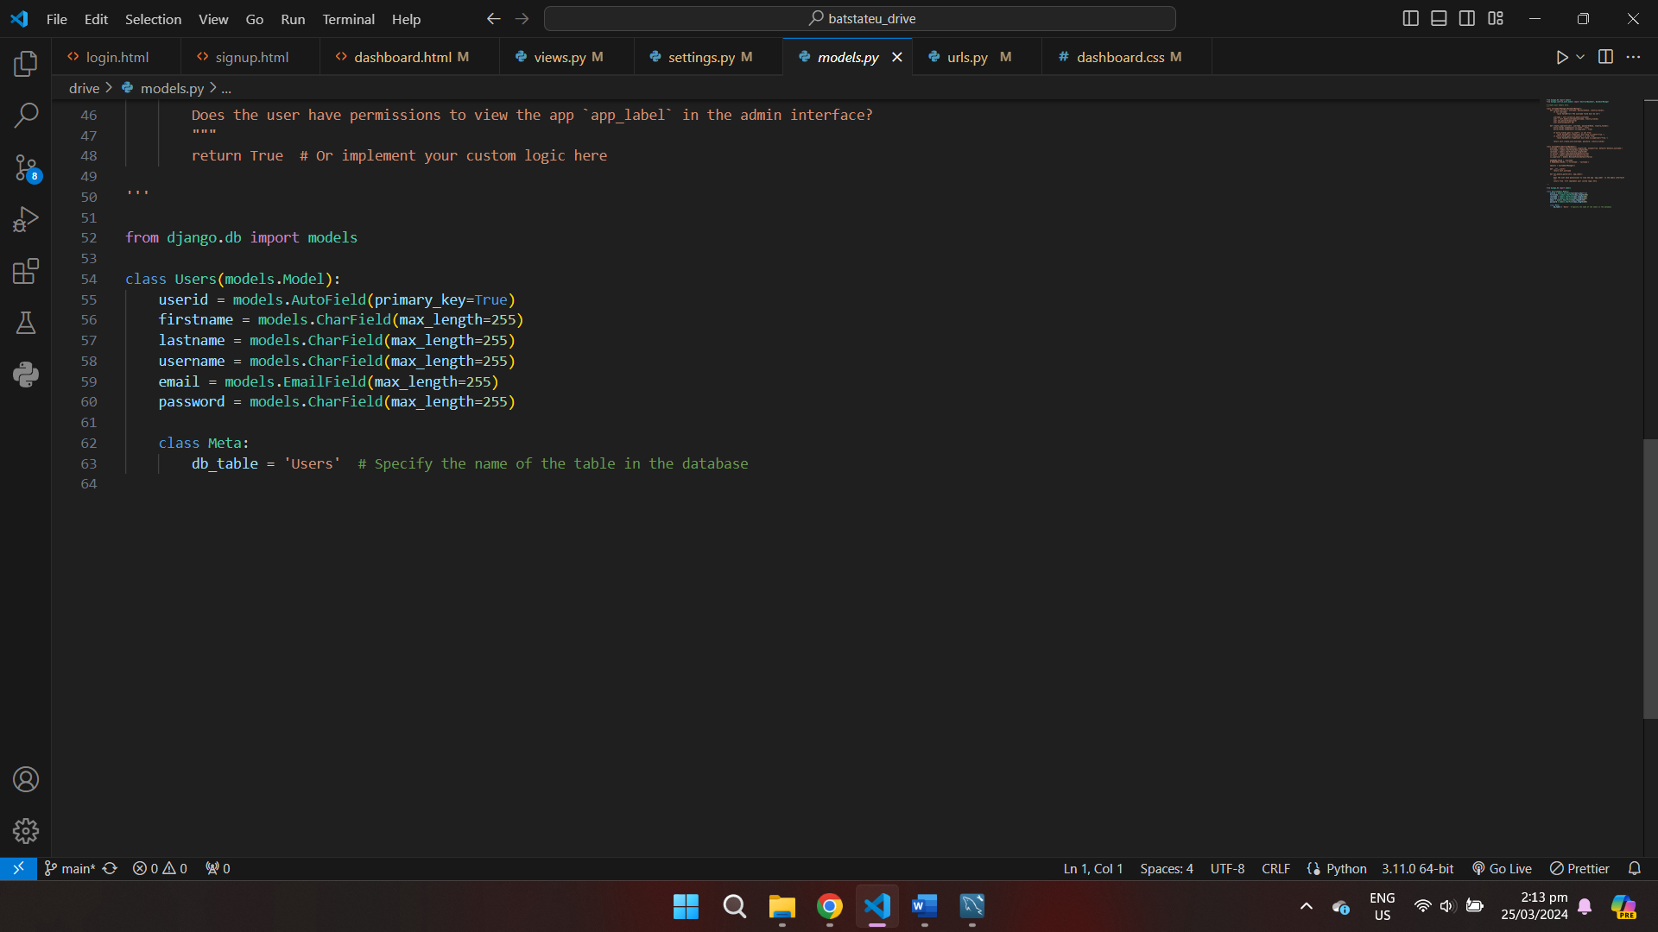

The initial model, created in MySQL Workbench, marks the beginning of our database design process. As we progress through development, additional table models will be created to support the evolving requirements of the entire project.

